Lab 12
VLAN Introduction
Objective:
The purpose of this lab is for the student to understand VLAN’s. Students will also utilize IOS commands to explore and configure VLAN’s.
Diagram:

Components:
6 – PC’s with an Ethernet NIC
1 – Switch
2 – 2 Port Routers
Procedure:
- Connect all PC’s together and put their static IP addresses, subnet masks and gateways on them. Test connectivity by pinging each machine within the network.

- On the diagram, label the routing tables below.
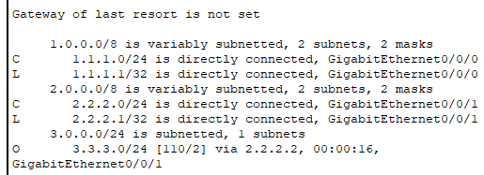
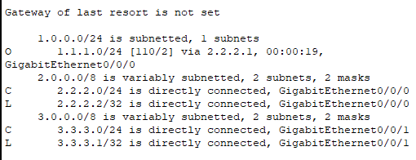

- Label the physical ports that the devices plug into on the switch on the diagram below.

- Label the chart below with what device is plugged into each switch port and what VLAN it should be on.

Port Device VLAN
FastEthernet0/1 PC 0 1
FastEthernet0/2 PC 1 1
FastEthernet0/3 Router 1 Gi0/0/0 1
FastEthernet0/4 PC 2 2
FastEthernet0/5 PC 3 2
FastEthernet0/6 Router 1 Gi0/0/1 2
FastEthernet0/7 Router 2 Gi0/0/0 2
FastEthernet0/8 PC 4 3
FastEthernet0/9 PC 5 3
FastEthernet0/10 Router 2 Gi0/0/1 3

- View the status of all the ports on the switch

  - What command did you enter?
Show interface status

  - What VLAN are all of the switch ports in? vlan1

  - Why? We have not configured the vlans yet and vlan1 is the default vlan

- Run the command show vlan

  - How does this command differ from the command shown above?
This command shows the vlan on the left instead of the port number, which is what is shows on the interface status

- Place FastEthernet0/1 into access mode and into vlan 1

  - What commands did you enter?
Int gi1/0/1
Switchport mode access
Switchport access vlan 1

- Place FastEthernet0/3 into access mode and into vlan 2

  - What commands did you enter?
Interface gigabitethernet1/0/3
Switchport mode access
Switchport access vlan 2

- View the running configuration

  - Does FastEthernet0/1 look the same as FastEthernet0/3? No
  - What is different and why? GigabitEthernet1/0/3 indicates that it is configured to vlan 2, while GigabitEthernet1/0/1 has no vlan displayed, probably because it’s on the default vlan 1

- Place switch ports FastEthernet0/1 - 10 into access mode and into the proper vlans.

  - What commands did you enter?
Int range gi1/0/1-3
Switchport mode access
Switchport access vlan 1

Int range gi1/0/4-7
Switchport mode access
Switchport access vlan 2

Int range gi1/0/8-10
Switchport mode access
Switchport access vlan 3

- Enable the router interfaces and place IP addresses on them.

- View Router 1’s routing table.

  - What routes are displayed?
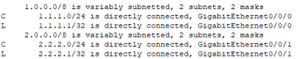
  - What routes are missing?
Network 3

- View Router 2’s routing table.

  - What routes are displayed?
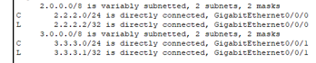
  - What routes are missing?
Network 1

- Enable the EIGRP routing protocol on router 1 with an AS of 1

  - What commands did you enter?
Router eigrp 1
Network 1.1.1.0 0.0.0.255
Network 2.2.2.0 0.0.0.255

- Enable the EIGRP routing protocol on router 2 with an AS of 1

  - What commands did you enter?
Router eigrp 1
Network 3.3.3.0 0.0.0.255
Network 2.2.2.0 0.0.0.255

- Verify the routing tables are correct on both routers.

- Can 1.1.1.10 ping 3.3.3.10? Yes

- Remove the EIGRP routing protocols on Router 1 and 2

  - What commands did you enter?
No router eigrp 1

- Enable the OSPF routing protocol on router 1 with Area of 0 and a process ID of 1
  - What commands did you enter?
Router ospf 1
Network 1.1.1.0 0.0.0.255 area 0
Network 2.2.2.0 0.0.0.255 area 0

- Enable the OSPF routing protocol on router 2 with Area of 0 and a process ID of 1.

  - What commands did you enter?
Router ospf 1
Network 3.3.3.0 0.0.0.255 area 0
Network 2.2.2.0 0.0.0.255 area 0

- Verify the routing tables are correct on both routers.

- Can 1.1.1.10 ping 3.3.3.10? Yes

- Remove the OSPF routing protocols on Router 1 and 2

  - What commands did you enter?
no router ospf 1

- Enable static routing on Router 1

  - What commands did you enter?
Ip route 3.3.3.0 255.255.255.0 2.2.2.2

- Enable static routing on Router 2

  - What commands did you enter?
Ip route 1.1.1.0 255.255.255.0 2.2.2.1

- Can 1.1.1.10 ping 3.3.3.10? yes

- Remove the static routes on Router 1 and 2

  - What commands did you enter?
No ip route 3.3.3.0 255.255.255.0 2.2.2.2
No ip route 1.1.1.0 255.255.255.0 2.2.2.1

- Please “write erase” your routers and switch(es). Also, Delete your vlan.dat file by issuing the following command: (delete flash:vlan.dat) on the switches. Not necessary on the routers.

- Draw the lab diagram below (PC’s, switch, and router connections) Label the IP addresses, and subnet masks of each device. Feel free to use packet tracer or Visio, but do not copy and paste the diagram at the beginning of the lab. Screen shot your diagram and paste it below. Label the routing tables next to the routers.

